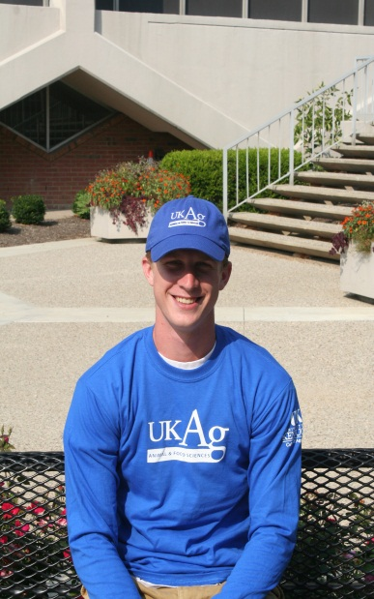

*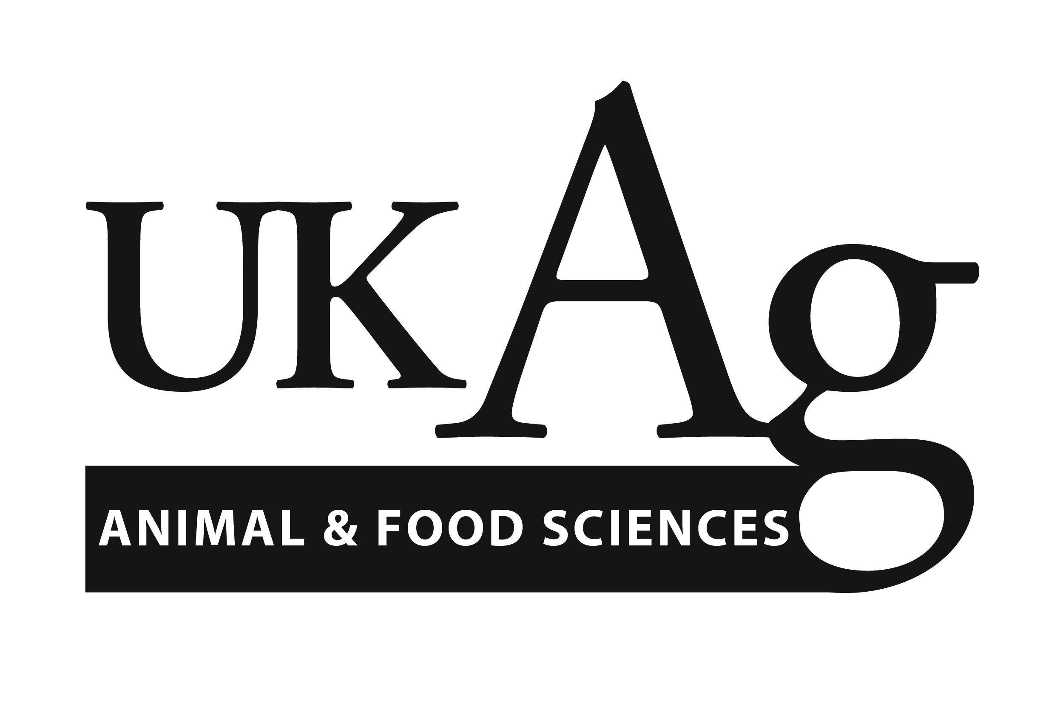*

Order your UKAg Animal and Food Sciences T-Shirt, Fleece, Polo, or Hat!!

**Booth in Ag North on Oct. 31 & Nov. 1, 2, 3**

C:\Program Files (x86)\Microsoft Office\MEDIA\OFFICE14\Bullets\BD21306_.gif Screen Printed/Embroidered T-Shirt

(Men’s and Women’s/Blue or Grey) - $10/$15

C:\Program Files (x86)\Microsoft Office\MEDIA\OFFICE14\Bullets\BD21306_.gif Screen Printed/Embroidered

Long Sleeve T-Shirt

(Men’s/Blue or Grey) - $15/$20

C:\Program Files (x86)\Microsoft Office\MEDIA\OFFICE14\Bullets\BD21306_.gif Dry-Fit Polo

(Men’s and Women’s / Blue) - $35

C:\Program Files (x86)\Microsoft Office\MEDIA\OFFICE14\Bullets\BD21306_.gif Polar Fleece

(Men’s and Women’s / Blue or Grey) - $35

Embroidered Hat (Blue) - $25

Contact Steffanie Burk for additional info: Steffanie.burk@uky.edu